The Blake CE Aided Primary School,  Cogges Hill Road,  Witney, Oxon, OX28 3FR  Tel: 01993 702840,  Fax: 01993 709439,  email: office.3600@blake.oxon.sch.uk  School website: http://www.blake.oxon.sch.uk  Headteacher: Tim Edwards-Grundy  Value of the Month: Caring  Newsletter Term 4 (6): April 2014 | 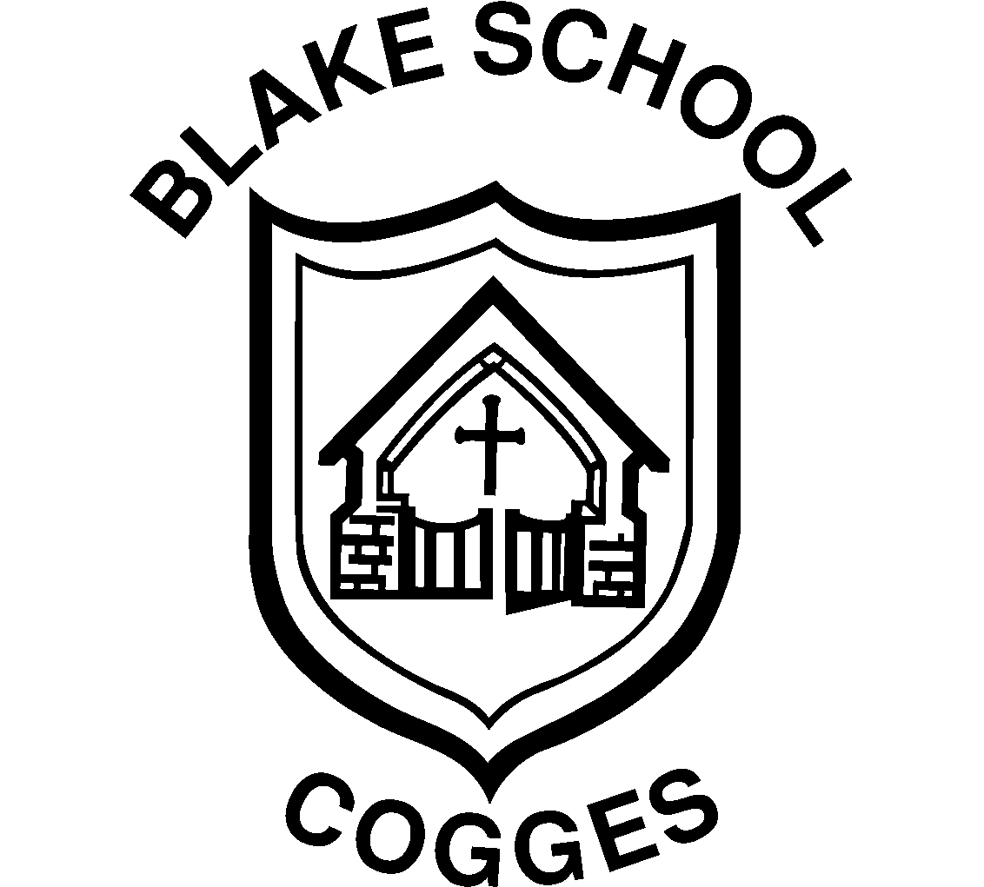  Committed to the care and education of your child within a Christian Setting.
Dear Parents/Carers,
We have come to the end of a very busy and successful term during which a lot of exciting things have happened. We have had the Blake School Marathon, Netball and Football competitions and a wonderful performance of Joseph and his Amazing Technicolour Dreamcoat by Years 3 and 4. Our School Council entertained the School Council from Christ the Sower School Milton Keynes, and everybody had a super day.
May I take this opportunity to wish you and your families a peaceful Easter break. I hope the weather remains kind to us all and look forward to seeing the children again in two weeks time.
Tim Edwards-Grundy

News Flash Items!

- The children return to school Tuesday 22nd April.

- Please be aware that it is possible the farm museum car park may be used for an event on Tuesday 22nd April. Parking may be limited


Years 3 and 4
On Wednesday 2nd April years 3 and 4 performed Andrew Lloyd-Webber and Tim Rice’s production. I was amazed at how brilliantly everyone remembered their words, or as Miss Main would say “awesome!” I really liked the costumes. All the songs were voted “the best” by the whole school (Who asked them? Beats me!) The acting was awesome. The script words and voice shows that Pharoah really did amazingly as Elvis Presley. ALL TOGETHER NOW… it was red and yellow and green and brown and…
Oscar Archibald yr 3 RP/HL

On Tuesday and Wednesday Years 3 and 4 did a play I was a narrator. I had to wear a white pillowcase with a hole at the end, some hair, silver things that went on my wrist and a necklace that I made. I had to sing Pharoah’s Story with Molly and Chloe. I also had to sing Stone the Crows. I was very nervous at the end of “Go go go Joseph” because that was when I was to sing. I was less worried for “Stone the Crows”. I really enjoyed it. If you watched it too, I hope you enjoyed it.
Edie Herbert yr 3 RP/HL


The Blake CE School
School Terms and Holiday Dates 2014

April holiday (Easter) 7th April – 21st April inclusive
Term 5: 22nd April – 23rd May 2014
May Day 5th May
Late Spring Hol 26th – 30th May inclusive
Inset Day Monday 2nd Jun
Term 6: 3rd June–18th July 2014
Inset Days 21st & 22nd July

Partnership Inset Days:
Monday 21st & Tuesday 22nd July 2014
Monday 2nd June

Dates for your Diary

Tues 22nd Apr Start of Term 5
w/c 12th May Yr. 6 SATS
Tues 13th May Yr. 2 Partnership Concert
Fri 23rd May End of Term 5
Mon 2nd June INSET Day
Tues 3rd Jun Start of Term 6
w/c 9th Jun RE and Art Week
New/updated diary dates will be added in red

School Clubs Term 4

Judo Club, Yrs 2-6 Monday 8.00-8.55am (Jonathan Gerrans)
Football Club Yrs 1-6 Monday 3.15-4.15pm (Premier Soccer)
Irish Dancing Monday 3.15-4.30pm (Natalie Mullins)
Chess Club Tuesday 3.30-4.30 (Mr. Morris)
Netball Tuesday 3.15-4.15 Yr. 6
Athletics Club Tuesday & Wednesday 3.15-4.15 Yrs 3-6 (Sam Hook)
Street Hockey Wednesday 3.15-4.15 Yrs 4-6
KS2 Choir Thursday 3.15-4.15 (Mrs. Raven)
Tag Rugby Thursday 3.15-4.15 Yrs 5 & 6 (Mrs. Bishop)
JAM Club Thursday 3.15-4.15 Yr. 6 (Mrs. Laithwaite)
Art Club Thursday 3.15-4.15 Yr. 2 (Mr. Steve Long)
JAM Club Friday 3.15-4.15 Yr. 5 (Mrs. Laithwaite)
Puzzle Club Yr. 3 Friday 3.20-4.10 (Mrs. Lynch)
Computer Club Yrs 3-6 Friday 3.20-4.20 (Computer Xplorers)

